Polímero | Sigla | estrutura química | SMILES | Tg (K) | Source
polystyrene | PS | 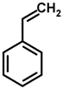 | C=Cc1ccccc1 | 373 | Polymer database
poly(methyl methacrylate) | PMMA | 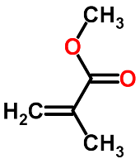 | COC(=O)C(=C)C | 378 | Polymer database
poly(ethyl methacrylate) | PEMA | 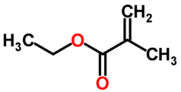 | CCOC(=O)C(=C)C | 338 | Polymer database
Poly(2-methylstyrene) | PMS | 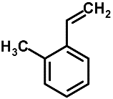 | C=Cc1ccccc1C | 409 | Polymer database
Poly(4-tert-butylstyrene) | PtBS | 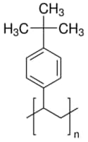 | CC(C)(C)c1ccc(C=C)cc1 | 413 | Sigma Aldritch
Poly(4-chlorostyrene) | PCLS | 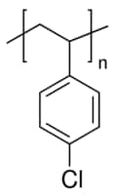 | Clc1ccc(C=C)cc1 | 379 | Sigma Aldritch
Poly(4-bromostyrene) | PMB | 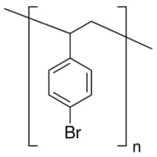 | C=Cc1ccc(cc1)Br | 411 | Polymer database
Poly(benzyl methacrylate) | PBzMA | 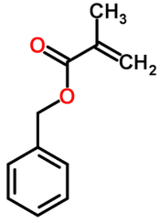 | O=C(C(=C)C)OCc1ccccc1 | 327 | Polymer database
Poly(cyclohexyl methacrylate) | PCHMA | 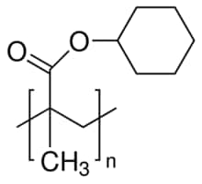 | CC(=C)C(=O)OC1CCCCC1 | 377 | Sigma Aldritch
Poly(butyl methacrylate) | PnBMA | 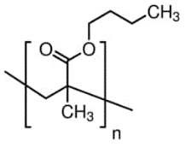 | CCCCOC(=O)C(C)=C | 303 | Sigma Aldritch
Poly(ethylene) | PE | 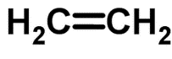 | C=C | 149 | Polymer database
Poly(acrylamide) | PAM | 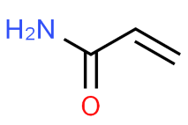 | OC(=N)C=C | 438 | Polymer database
Poly[(N-tert-butylaminocarbonyl)ethylene] |  | 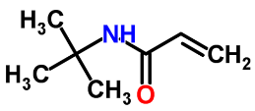 | C=CC(=O)NC(C)(C)C | 401 | Polymer database
Poly(N-isopropyl acrylamide) |  | 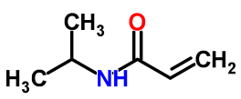 | C=CC(=O)NC(C)C | 403 | Polymer database
Poly[(N-octylaminocarbonyl)ethylene] |  | 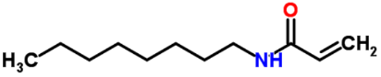 | CCCCCCCCNC(=O)C=C | 220 | Polymer database
Poly[(N-phenylaminocarbonyl)ethylene] |  | 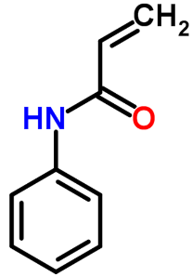 | C=CC(=O)Nc1ccccc1 |  | Polymer database
Poly[(N-sec-butylaminocarbonyl)ethylene] |  | 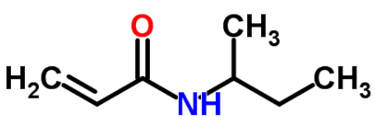 | C=CC(=O)NC(C)CC | 390 | Polymer database
Poly(acrylic acid) | PAA | 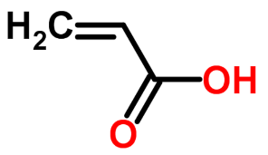 | OC(=O)C=C | 374 | Polymer database
Poly(benzyl acrylate) |  | 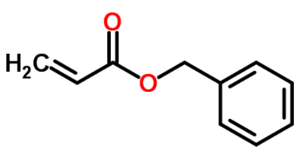 | C=CC(=O)OCc1ccccc1 | 282 | Polymer database
Poly(butyl acrylate) |  | 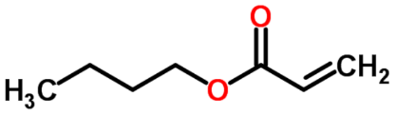 | CCCCOC(=O)C=C | 220 | Polymer database
Poly(4-chlorophenyl acrylate) |  | 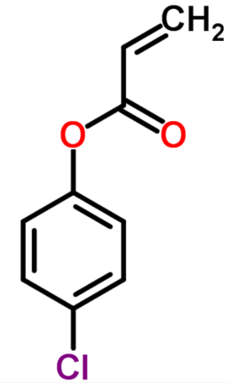 | C=CC(=O)Oc1ccc(cc1)Cl | 331 | Polymer database
Poly(2-cyanoethyl acrylate) |  | 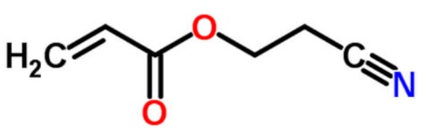 | C=CC(=O)OCCC#N | 277 | Polymer database
Poly(cyanomethyl acrylate) |  | 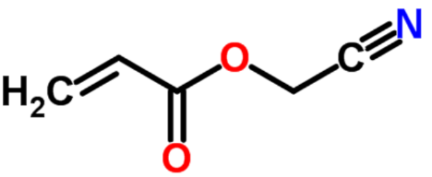 | C=CC(=O)OCC#N | 296 | Polymer database
Poly(cyclohexyl acrylate) |  | 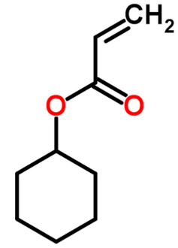 | C=CC(=O)OC1CCCCC1 | 289 | Polymer database
Poly(ethyl acrylate) |  | 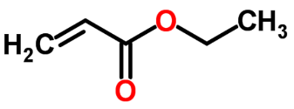 | CCOC(=O)C=C | 250 | Polymer database
Poly(2-ethylhexyl acrylate) |  | 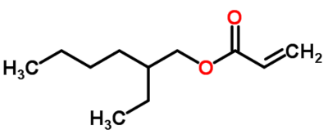 | CCCCC(COC(=O)C=C)CC | 221 | Polymer database
Poly(hexyl acrylate) |  | 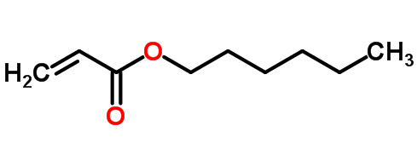 | CCCCCCOC(=O)C=C | 215 | Polymer database
Poly(isobutyl acrylate) |  | 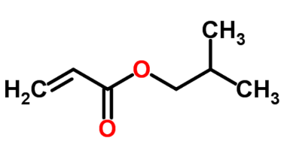 | C=CC(=O)OCC(C)C | 240 | Polymer database
Poly(isopropyl acrylate) |  | 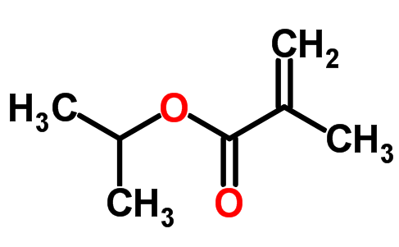 | CC(C)OC(=O)C=C | 271 | Polymer database
Poly(methyl acrylate) |  | 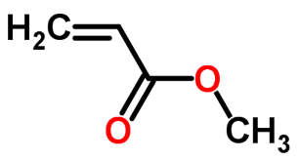 | COC(=O)C=C | 280 | Polymer database
Poly(n-octyl acrylate) |  | 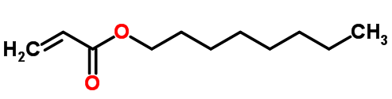 | CCCCCCCCOC(=O)C=C | 208 | Polymer database
Poly(propyl acrylate) |  | 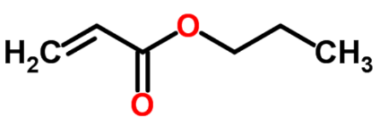 | CCCOC(=O)C=C | 231 | Polymer database
Poly(sec-butyl acrylate) |  | 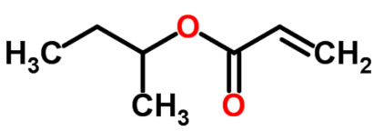 | CC(OC(=O)C=C)CC | 253 | Polymer database
Poly(octadecyl acrylate) |  | 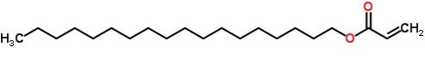 | CCCCCCCCCCCCCCCC  CCCCCCCCCCOC(=O)C=C | 311 | Polymer database
Poly(tert-butyl acrylate) |  | 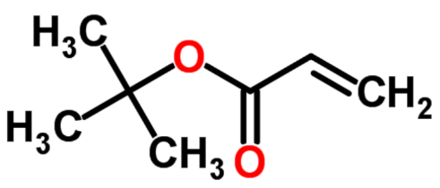 | C=CC(=O)OC(C)(C)C | 311 | Polymer database
Poly(2,2,3,3-tetrafluoropropyl acrylate) |  | 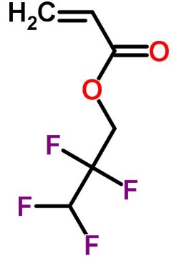 | FC(F)C(F)(F)COC(=O)C(=C) | 249 | Polymer database
Poly(acrylonitrile) |  | 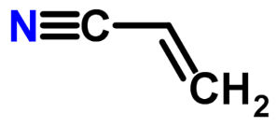 | C=CC#N | 383 | Polymer database
Poly(methacrylonitrile) |  | 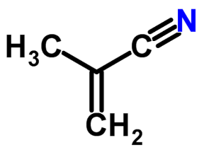 | CC(=C)C#N | 388 | Polymer database
Poly(butylene adipate) |  | 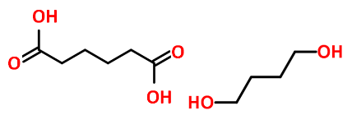 | OC(=O)CCCCC(=O)O.OCCCCO | 202 | Polymer database
Poly(ethylene adipate) |  | 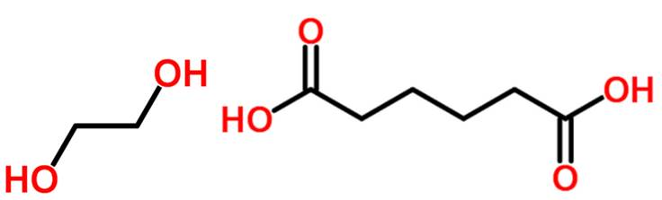 | OC(=O)CCCCC(=O)O.OCCO | 230 | Polymer database
Poly(1,3-propylene adipate) |  | 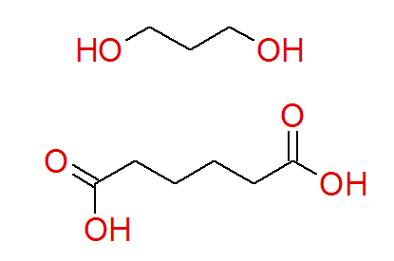 | OC(=O)CCCCC(=O)O.OCCCO | 215 | Polymer database
Poly(ethyl ethylene |  | 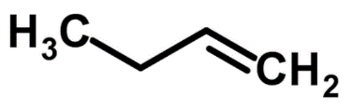 | CCC=C | 245 | Polymer database
Poly(butyl ethylene) |  | 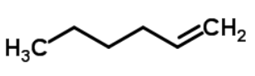 | CCCCC=C | 223 | Polymer database
Poly(cyclohexylethylene) |  | 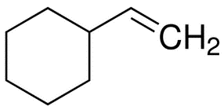 | C=CC1CCCCC1 | 400 | Polymer database
Poly(heptylethylene) |  | 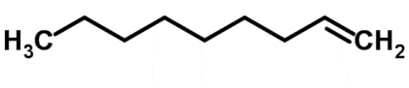 | CCCCCCCC=C | 225 | Polymer database
Poly(hexylethylene) |  | 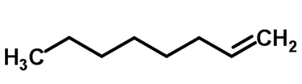 | CCCCCCC=C | 218 | Polymer database
Poly(isobutene) |  | 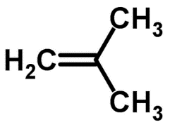 | CC(=C)C | 202 | Polymer database
Poly(isobutylethylene) |  | 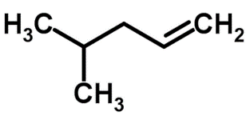 | C=CCC(C)C | 302 | Polymer database
Poly(isopropylethylene |  | 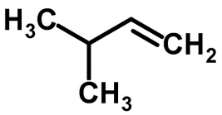 | C=CC(C)C | 323 | Polymer database
Poly(1-ethyl-1-methylethylene) |  | 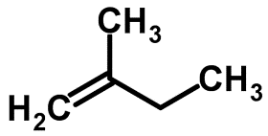 | C=C(C)CC | 268 | Polymer database
Poly(octylethylene) |  | 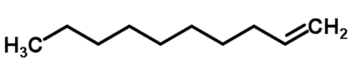 | CCCCCCCCC=C | 232 | Polymer database
Poly(pentylethylene) |  | 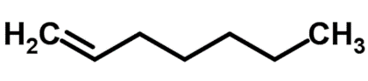 | CCCCCC=C | 231 | Polymer database
Poly(propylene) | PP | 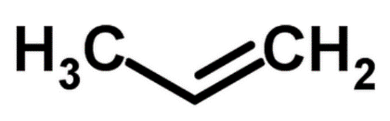 | CC=C | 264 | Polymer database
Poly(propylethylene) |  | 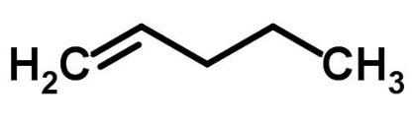 | CCCC=C | 238 | Polymer database
Poly(tert-butylethylene) |  | 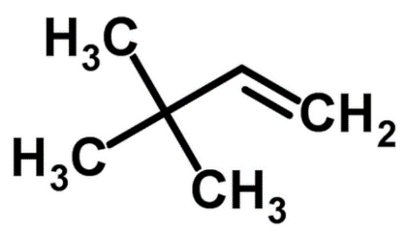 | C=CC(C)(C)C | 337 | Polymer database
Polyamide 3 | PA3 | 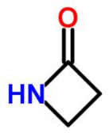 | C1CNC1=O | 384 | Polymer database
Polyamide 6 | PA6 | 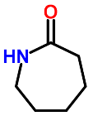 | O=C1CCCCCN1 | 325 | Polymer database
Polyamide 8 | PA8 | 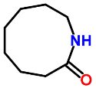 | O=C1CCCCCCCN1 | 324 | Polymer database
Polyamide 11 | PA11 | 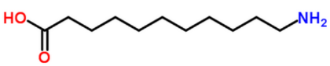 | NCCCCCCCCCCC(=O)O | 315  344 | Polymer database
Polyamide 12 | PA12 | 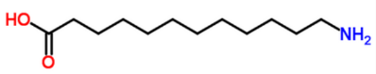 | NCCCCCCCCCCCC(=O)O | 313 | Polymer database
Polyamide 4-6 | PA4-6 | 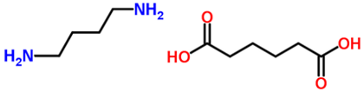 | OC(=O)CCCCC(=O)O.NCCCCN | 353 | Polymer database
Polyamide 6-6 | PA6-6 | 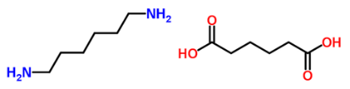 | NCCCCCCN.OC(=O)CCCCC(=O)O | 324 | Polymer database
Polyamide 6-9 | PA6-9 | 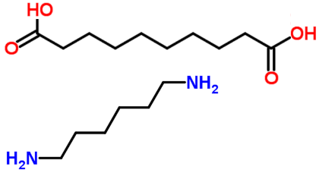 | OC(=O)CCCCCCCC(=O)O.NCCCCCCN | 332 | Polymer database
Polyamide 6-10 | PA6-10 |  | OC(=O)CCCCCCCCC(=O)O.NCCCCCCN | 323 | Polymer database
Polyamide 6-12 | PA6-12 | 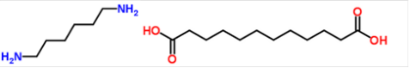 | NCCCCCCN.OC(=O)CCCCCCCCCCC(=O)O | 319 | Polymer database
Polyamide 10-10 | PA10-10 | 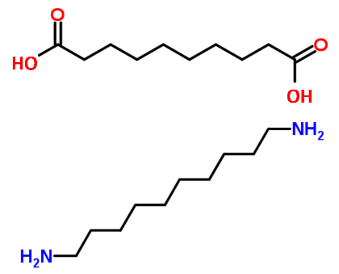 | OC(=O)CCCCCCCCC(=O)O.NCCCCCCCCCCN | 323 | Polymer database
Poly(iminoisophthaloyliminohexamethylene | PA 6I | 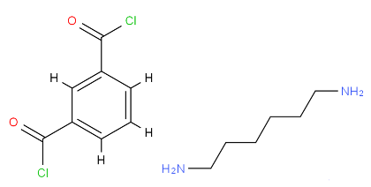 | NCCCCCCN.ClC(=O)c1cc(ccc1)C(=O)Cl | 395 | Polymer database
Poly(hexamethylene teraphthalamide) | PA 6T | 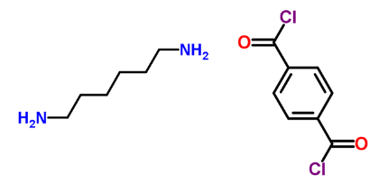 | NCCCCCCN.ClC(=O)c1ccc(cc1)C(=O)Cl | 412 | Polymer database
Poly(p-phenylene terephthalamide) | PPTA | 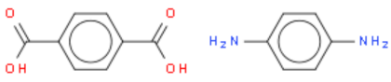 | Nc1ccc(cc1)N.ClC(=O)c1ccc(cc1)C(=O)Cl | 600 | Polymer database
Poly(nonamethylene teraphthalamide) | PP 9T | 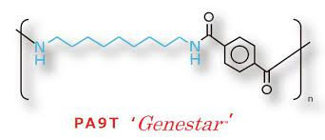 | NCCCCCCCCCN.ClC(=O)c1ccc(cc1)C(=O)Cl | 394 | Polymer database
Poly(m-phenylene terephthalamide) | MPDI | 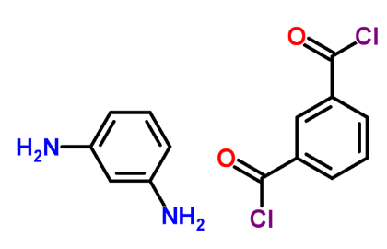 | Nc1cc(ccc1)N.ClC(=O)c1cc(ccc1)C(=O)Cl | 537 | Polymer database
Poly(4,4'-pentamethylenedibenzoic anhydride) |  | 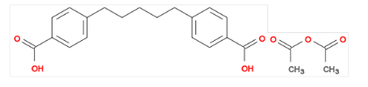 | OC(=O)c1ccc(cc1)CCCCCc1ccc(cc1)C(=O)O.CC(=O)OC(=O)C | 320 | Polymer database
Poly(p-tetramethylenedibenzoic anhydride) |  | 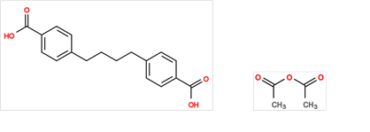 | OC(=O)c1ccc(cc1)CCCCc1ccc(cc1)C(=O)O.CC(=O)OC(=O)C | 316 | Polymer database
Poly(sebacic anhydride) |  | 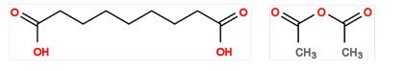 | OC(=O)CCCCCCCCC(=O)O.CC(=O)OC(=O)C |  | Polymer database
Poly(azelaic anhydride) |  | 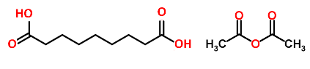 | OC(=O)CCCCCCCC(=O)O.CC(=O)OC(=O)C |  | Polymer database
Poly(1,2-butadiene) |  | 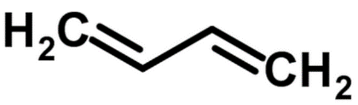 | C=CC=C | 261 | Polymer database
Poly(1,4-butadiene) | PBD |  | C=CC=C | 171 | Polymer database
Poly(1-pentenylene) | PCP, PPT, CPR |  | C1CC=CC1 | 178 | Polymer database
Poly(1-ethyl-1,4-butadiene) |  | 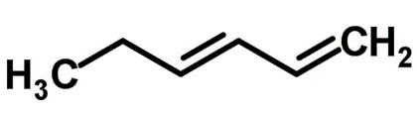 | CCC=CC=C | 197 | Polymer database
Polyisoprene | IR | 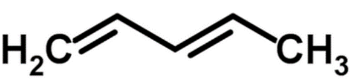 | CC=CC=C | 204 | Polymer database
Poly(1,4-pentadiene) |  | 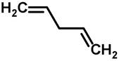 | C=CCC=C |  | Polymer database
Poly(dimethyl fumarate) |  | 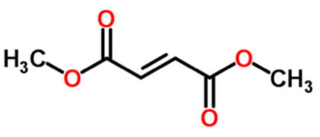 | COC(=O)/C=C/C(=O)OC | 373 | Polymer database
Poly(dibutyl fumarate) |  | 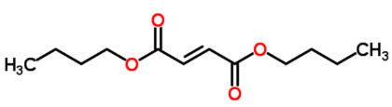 | CCCCOC(=O)/C=C/C(=O)OCCCC |  | Polymer database
Poly(diethyl fumarate) |  | 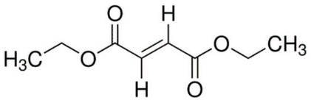 | CCOC(=O)/C=C/C(=O)OCC | 284 | Polymer database
Poly(dipropyl fumarate) |  | 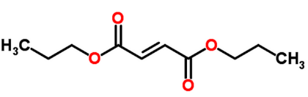 | CCCOC(=O)/C=C/C(=O)OCCC | 268 | Polymer database
Poly(chlorotrifluoroethylene) | PCTFE, PTFCE | 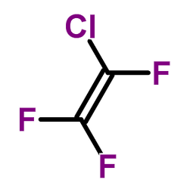 | FC(=C(F)F)Cl | 360 | Polymer database
Poly(tetrafluoroethylene) | PTFE | 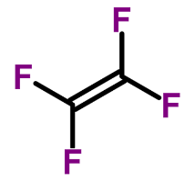 | FC(=C(F)F)F | 392  211 | Polymer database
Poly(vinyl bromide) |  | 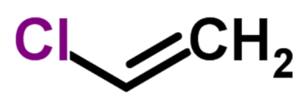 | BrC=C | 373 | Polymer database
Poly(vinyl chloride) | PVC | 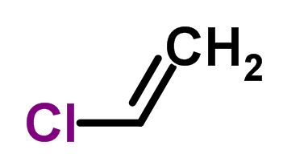 | ClC=C | 350  375 | Polymer database
Poly(vinyl fluoride) | PVF | 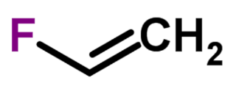 | FC=C | 253  326 | Polymer database
Poly(vinylidene chloride) | PVDC | 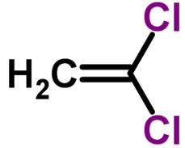 | ClC(=C)Cl | 256  284 | Polymer database
Poly(vinylidene fluoride) | PVDF | 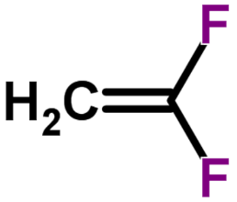 | FC(=C)F | 242 | Polymer database
Poly(Bisphenol A-co-epichlorohydrin) |  | 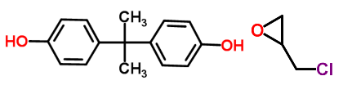 | CC(C)(c1ccc(cc1)O)c2ccc(cc2)O.C1C(O1)CCl | 372 | Polymer database
Poly(Bisphenol F-co-epichlorohydrin) | DGEBF | 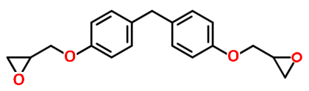 | O1C C1COc1ccc(cc1)Cc1ccc(cc1)OC C1O C1 | 353 | Polymer database
Poly(bisphenol-A diglycidyl ether- alt - ethylenediamine), |  | 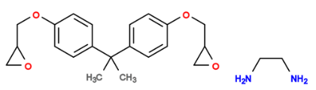 | CC(c1ccc(cc1)OCC1OC1)(c1ccc(cc1)OCC1OC1)C.NCCN | 410 | Polymer database
Poly(bisphenol-A diglycidyl ether-alt-1,6-diamino hexane) |  | 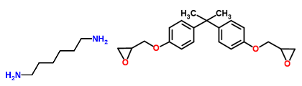 | CC(c1ccc(cc1)OCC1OC1)(c1ccc(cc1)OCC1OC1)C.NCCCCCCN | 386 | Polymer database
Poly(bisphenol A isophthalate) |  | 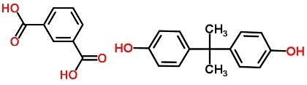 | OC(=O)c1cc(ccc1)C(=O)O.Oc1ccc(cc1)C(C)(C)c2ccc(cc2)O | 462 | Polymer database
Poly(Bisphenol A terephthalate) |  | 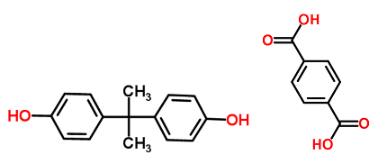 | OC(=O)c1ccc(cc1)C(=O)O.Oc1ccc(cc1)C(C)(C)c2ccc(cc2)O | 472 | Polymer database
Poly(tetramethylene isophthalate) |  | 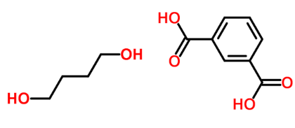 | OC(=O)c1cccc(c1)C(=O)O.OCCCCO | 297 | Polymer database
Poly(1,4-butylene sebacate) |  | 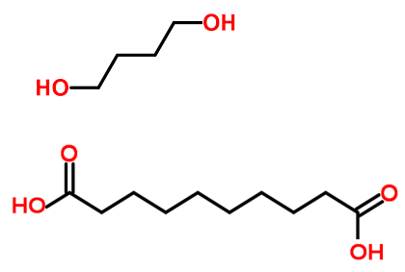 | OC(=O)CCCCCCCCC(=O)O.OCCCCO | 214 | Polymer database
Poly(1,4-butylene succinate) |  | 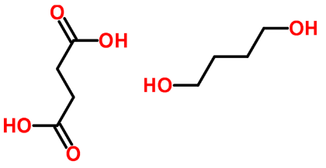 | OC(=O)CCC(=O)O.OCCCCO | 238 | Polymer database
Poly[(tetramethylene terephthalate), | PBT | 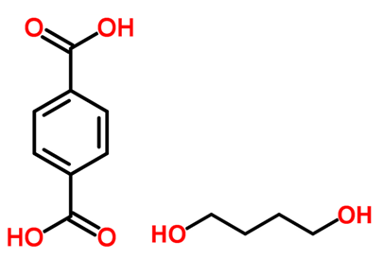 | OC(=O)c1ccc(cc1)C(=O)O.OCCCCO | 313 | Polymer database
Poly(ethylene sebacate) |  | 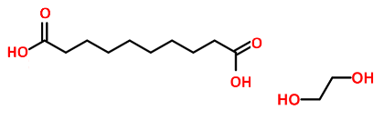 | OC(=O)CCCCCCCCC(=O)O.OCCO | 244 | Polymer database
Poly(ethylene succinate) |  | 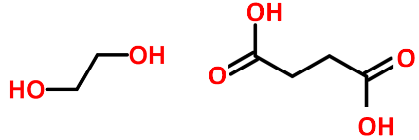 | OC(=O)CCC(=O)O.OCCO | 267 | Polymer database
Poly(caprolactone) | PCL | 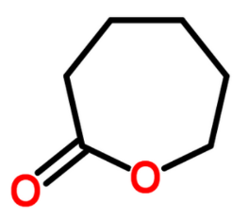 | O=C1CCCCCO1 | 207 | Polymer database
Poly(cyclohexanedimethylene terephthalate) | PCT | 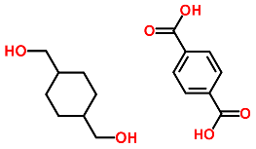 | OC(=O)c1ccc(cc1)C(=O)O.OCC1CCC(CC1)CO | 364 | Polymer database
Poly(ethylene adipate) |  |  | OC(=O)CCCCC(=O)O.OCCO | 230 | Polymer database
Poly(ethylene isophthalate) |  | 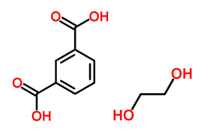 | OC(=O)c1cccc(c1)C(=O)O.OCCO | 324 | Polymer database
Poly(ethylene 2,6-naphthalate) | PEN | 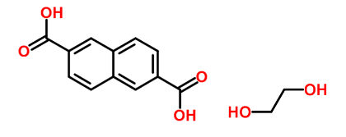 | OC(=O)c1ccc2c(c1)ccc(c2)C(=O)O.OCCO | 392 | Polymer database
Poly(ethylene phthalate) |  | 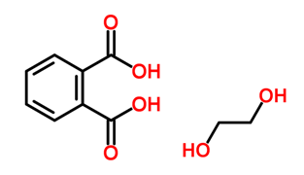 | OC(=O)c1ccccc1C(=O)O.OCCO | 297 | Polymer database
Poly(ethylene terephthalate) | PET | 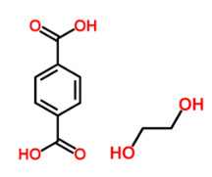 | OC(=O)c1ccc(cc1)C(=O)O.OCCO | 344 | Polymer database
Polyglycolide | PGA | 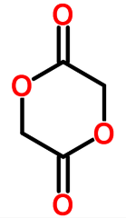 | O=C1OCC(=O)OC1 | 312 | Polymer database
Poly(1,6-hexylene sebacate) |  | 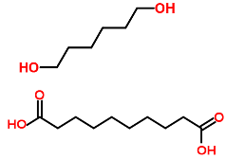 | OC(=O)CCCCCCCCC(=O)O.OCCCCCCO | 213 | Polymer database
Poly(1,6-hexylene succinate) |  | 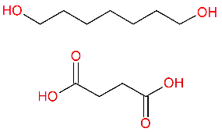 | OC(=O)CCC(=O)O.OCCCCCCO | 220 | Polymer database
Poly(3-hydroxybutyrate) | P3HB, PHB | 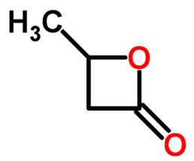 | CC1CC(=O)O1 | 276 | Polymer database
Poly(4-hydroxybutyrate) | P4HB | 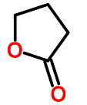 | O=C1CCCO1 | 221 | Polymer database
Polylactic acid, | PLA | 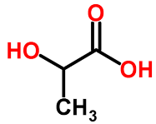 | OC(=O)C(O)C | 332 | Polymer database
Poly(1,3-propylene adipate) |  |  | OC(=O)CCCCC(=O)O.OCCCO | 215 | Polymer database
Poly(1,3-propylene succinate) |  | 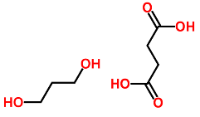 | OC(=O)CCC(=O)O.OCCCO | 232 | Polymer database
Poly(trimethylene terephthalate) | PTT | 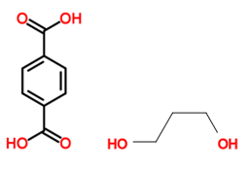 | OC(=O)c1ccc(cc1)C(=O)O.OCCCO | 326 | Polymer database
Polyacetal | POM | 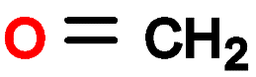 | C=O | 211 | Polymer database
Poly(3-butoxypropylene oxide) |  | 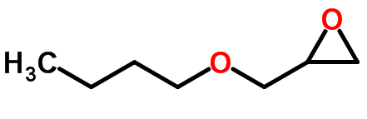 | CCCCOCC1CO1 | 194 | Polymer database
Poly(epichlorohydrin) |  | 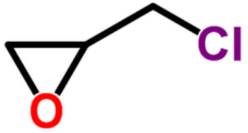 | ClCC1CO1 | 253 | Polymer database
Poly(ethylene glycol) | PEO, POE, PEG | 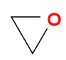 | O1CC1 | 225 | Polymer database
Poly(hexamethylene glycol) |  | 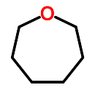 | C1CCCCOC1 | 204 | Polymer database
Poly(3-methoxypropylene oxide) |  | 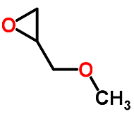 | COCC1CO1 | 211 | Polymer database
Poly[oxy(hexyloxymethyl)ethylene] |  | 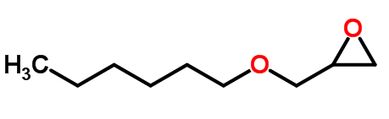 | CCCCCCOCC1CO1 | 189 | Polymer database
Poly(methylene oxide-co-ethylene oxide) |  | 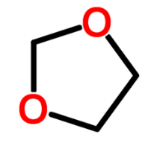 | C1COCO1 | 209 | Polymer database
Poly(propylene glycol) | PPG | 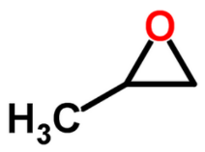 | CC1CO1 | 205 | Polymer database
Poly(tetrahydrofuran) | PTMO, PTMEG | 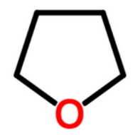 | C1CCCO1 | 189 | Polymer database
Poly(trimethylene glycol) |  |  | C1CCO1 | 197 | Polymer database
Poly[1,1-bis(chloromethyl)trimethylene oxide] |  | 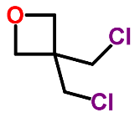 | C1C(CO1)(CCl)CCl | 272 | Polymer database
Poly(ether ketone) | PEK | 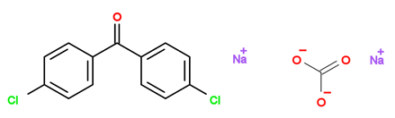 | [O-]C(=O)[O-].[Na+].[Na+].O=C(c1ccc(cc1)Cl)c1ccc(cc1)Cl | 431 | Polymer database
Poly(ether ether ketone) | PEKK | 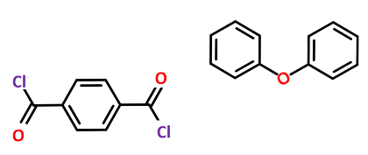 | c1cc(ccc1C(=O)Cl)C(=O)Cl.c1ccc(cc1)Oc2ccccc2 | 437 | Polymer database
Poly(ether ether ketone) | PEEK | 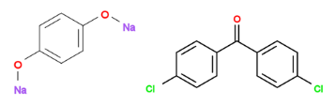 | [Na]Oc1ccc(cc1)O[Na].O=C(c1ccc(cc1)Cl)c1ccc(cc1)Cl | 421 | Polymer database
Poly(ethyleneketone) |  | 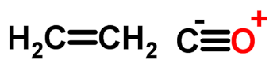 | C=C.[C-]#[O+] | 291 | Polymer database
Poly(propyleneketone) | PPK | 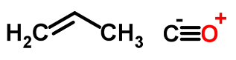 | CC=C.[C-]#[O+] | 312 | Polymer database
Poly(ether ether sulfone) | PEES | 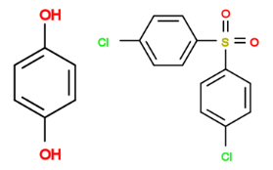 | Oc1ccc(cc1)O.Clc1ccc(cc1)S(=O)(=O)c1ccc(cc1)Cl | 479 | Polymer database
Poly(ethersulfone) | PES | 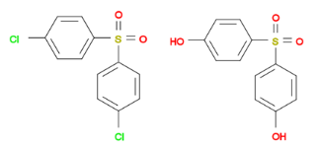 | Clc1ccc(cc1)S(=O)(=O)c1ccc(cc1)Cl.Oc1ccc(cc1)S(=O)(=O)c1ccc(cc1)O | 490 | Polymer database
Poly(phenylsulfone) | PPSU PPSF | 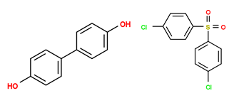 | Oc1ccc(cc1)c1ccc(cc1)O.Clc1ccc(cc1)S(=O)(=O)c1ccc(cc1)Cl | 482 | Polymer database
Bisphenol A Polysulfone | PSU  PSF | 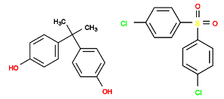 | CC(c1ccc(cc1)O)(c1ccc(cc1)O)C.Clc1ccc(cc1)S(=O)(=O)c1ccc(cc1)Cl | 459 | Polymer database
Polychloroprene |  | 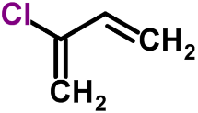 | C=CC(=C)Cl | 237 | Polymer database
Poly(1-bromo-1-butenylene) |  | 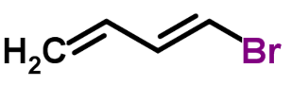 | BrC=CC=C | 233 | Polymer database
Poly(2-chlorostyrene) |  | 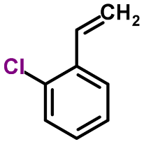 | C=Cc1ccccc1Cl | 395 | Polymer database
Poly(3-chlorostyrene) |  | 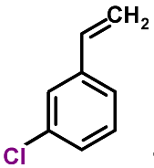 | C=Cc1cccc(c1)Cl | 363 | Polymer database
Poly(4-chlorostyrene) |  | 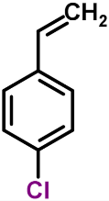 | C=Cc1ccc(cc1)Cl | 398 | Polymer database
Poly(2,5-difluorostyrene) |  | 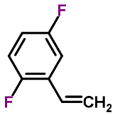 | C=Cc1cc(F)ccc1F | 374 | Polymer database
Poly(4-fluorostyrene) |  | 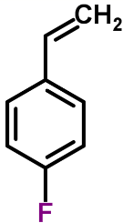 | C=Cc1ccc(cc1)F | 376 | Polymer database
Poly(2-hydroxyethyl acrylate) | PHEA | 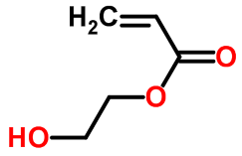 | C=CC(=O)OCCO | 259 | Polymer database
Poly(2-hydroxyethyl methacrylate) | PHEMA | 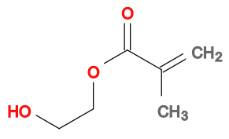 | CC(=C)C(=O)OCCO | 358  393 | Polymer database
Poly(2-hydroxypropyl methacrylate) | PHPMA | 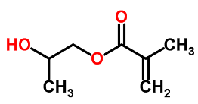 | CC(COC(=O)C(=C)C)O | 349 | Polymer database
Poly[(diethylene glycol)-alt-(1,6-hexamethylene diisocyanate)], | PEG 100 - HMDI | 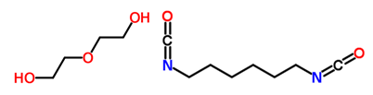 | OCCOCCO.O=C=NCCCCCCN=C=O | 281 | Polymer database
Poly[(tetraethylene glycol)-alt-(1,6-hexamethylene diisocyanate)], | PEG 200 - HMDI | 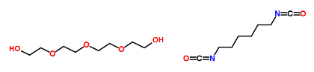 | OCCOCCOCCOCCO.O=C=NCCCCCCN=C=O | 258 | Polymer database
Poly[(1,4-butanediol)-alt-(4,4'-diphenylmethane diisocyanate)] | MDI-BD | 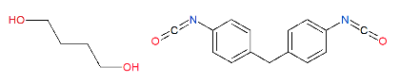 | OCCCCO.O=C=Nc1ccc(cc1)Cc1ccc(cc1)N=C=O | 363 | Polymer database
Poly{(ethylene glycol)-alt-[bis(4-isocyanatophenyl)methane]} | EG - MDI | 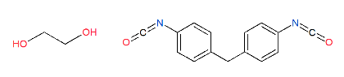 | OCCO.O=C=Nc1ccc(cc1)Cc1ccc(cc1)N=C=O | 412 | Polymer database
Poly[(tetramethylene ether glycol 1000)-alt-(4,4'-diphenylmethane diisocyanate)], | PTMG 1000 - MDI | 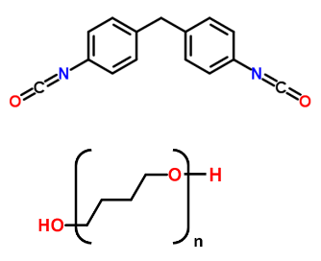 | (OCCCC)14O.O=C=Nc1ccc(cc1)Cc1ccc(cc1)N=C=O | 223 | Polymer database
Poly(bisphenol A isophthalate) |  | 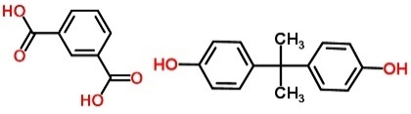 | OC(=O)c1cc(ccc1)C(=O)O.Oc1ccc(cc1)C(C)(C)c2ccc(cc2)O | 462 | Polymer database
Poly(tetramethylene isophthalate) |  |  | OC(=O)c1cccc(c1)C(=O)O.OCCCCO | 297 | Polymer database
Poly(ethylene isophthalate) |  |  | OC(=O)c1cccc(c1)C(=O)O.OCCO | 324 | Polymer database
Poly(dimethyl itaconate) |  | 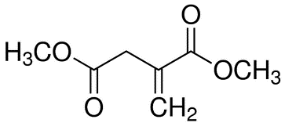 | COC(=O)CC(=C)C(=O)OC | 373 | Polymer database
Poly[di(n-propyl) itaconate] |  | 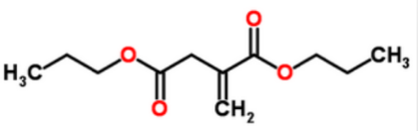 | CCCOC(=O)CC(=C)C(=O)OCCC | 306 | Polymer database
Poly[di(n-butyl) itaconate |  | 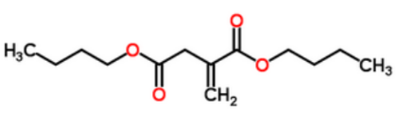 | CCCCOC(=O)CC(=C)C(=O)OCCCC | 285 | Polymer database
Poly[di(n-hexyl) itaconate] |  | 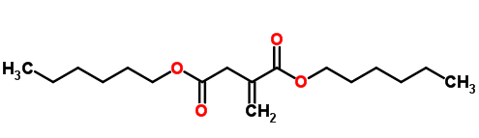 | CCCCCCOC(=O)CC(=C)C(=O)OCCCCCC | 255 | Polymer database
Poly(N-acetylmethacrylamide) |  |  | CC(=O)NC(=O)C(=C)C |  | Polymer database
Poly(N-benzyl methacrylamide) |  | 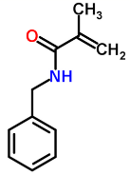 | O=C(C(=C)C)NCc1ccccc1 |  | Polymer da Polymer database tabase
Polymethacrylamide | PMAAM | 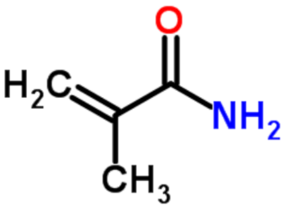 | CC(=C)C(=O)N | 486,5 | Polymer database
Poly(N-tert-butylmethacrylamide) |  | 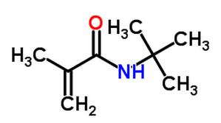 | CC(=C)C(=O)NC(C)(C)C | 433 | Polymer database
Poly(p-phenylene) | PPP | 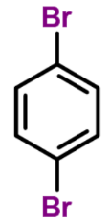 | Brc1ccc(cc1)Br | 538 | Polymer database
Poly(p-phenylene vinylene) | PPV | 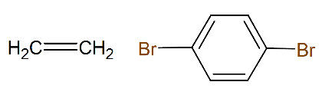 | Brc1ccc(cc1)Br.C=C | 353 | Polymer database
Poly(p-xylene) |  | 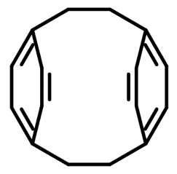 | C1Cc2ccc(cc2)CCc2ccc1cc2 | 343 | Polymer database
Poly(2-chloro-p-xylylene) |  | 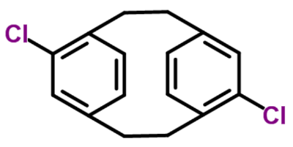 | Clc1cc2CCc3ccc(CCc1cc2)cc3Cl | 358 | Polymer database
Poly(2,6-dimethyl-p-phenylene oxide) | PPO  PPE | 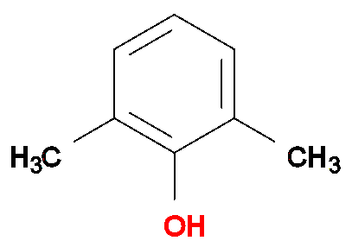 | Oc1c(C)cccc1(C) | 483 | Polymer database
Poly(2,6-diphenyl-p-phenylene oxide) |  | 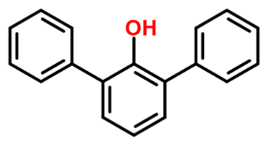 | Oc1c(cccc1c1ccccc1)c1ccccc1 | 497 | Polymer database
Poly(p-phenylene oxide) | PPO, PPE | 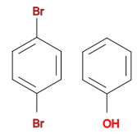 | Brc1ccc(Br)cc1.Oc1ccccc1 | 361 | Polymer database
Poly(ether ether sulfone) | PEES | 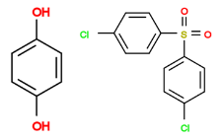 | Oc1ccc(cc1)O.Clc1ccc(cc1)S(=O)(=O)c1ccc(cc1)Cl | 479 | Polymer database
Poly(ethersulfone) | PES | 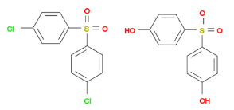 | Clc1ccc(cc1)S(=O)(=O)c1ccc(cc1)Cl.Oc1ccc(cc1)S(=O)(=O)c1ccc(cc1)O | 490 | Polymer database
Poly(phenylsulfone) | PPSU PPSF |  | Oc1ccc(cc1)c1ccc(cc1)O.Clc1ccc(cc1)S(=O)(=O)c1ccc(cc1)Cl | 482 | Polymer database
Bisphenol A Polysulfone | PSU  PSF | 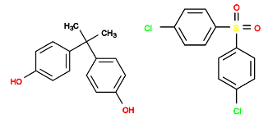 | CC(c1ccc(cc1)O)(c1ccc(cc1)O)C.Clc1ccc(cc1)S(=O)(=O)c1ccc(cc1)Cl | 459 | Polymer database
Poly(1,4-phenylene sulfide) | PPS | 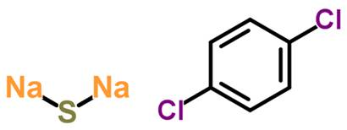 | Clc1ccc(cc1)Cl.[Na]S[Na] | 363 | Polymer database
Poly(ethylene sulfide) | TR | 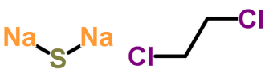 | ClCCCl.[Na]S[Na] | 223 | Polymer database
Poly(propylene sulfide) |  | 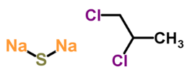 | ClCC(C)Cl.[Na]S[Na] | 228 | Polymer database
Poly(1,4-butylene sebacate) |  | 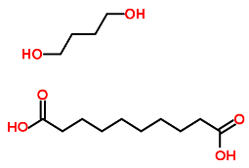 | OC(=O)CCCCCCCCC(=O)O.OCCCCO | 214 | Polymer database
Poly(ethylene sebacate) |  |  | OC(=O)CCCCCCCCC(=O)O.OCCO | 244 | Polymer database
Poly(1,6-hexylene sebacate) |  | 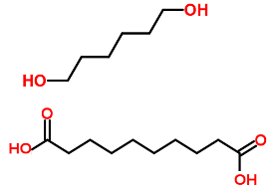 | OC(=O)CCCCCCCCC(=O)O.OCCCCCCO | 213 | Polymer database
Poly(diethylsiloxane) | PDES | 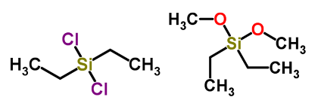 | CC[Si](CC)(Cl)Cl, CC[Si](CC)(OC)OC | 137 | Polymer database
Poly(dimethylsiloxane) | PDMS | 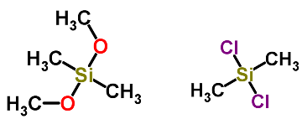 | C[Si](C)(Cl)Cl, CO[Si](C)(C)OC | 149 | Polymer database
Poly(methylphenylsiloxane) | PMPS | 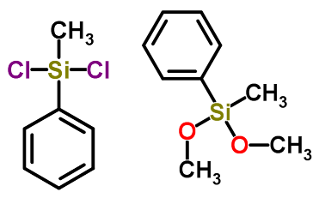 | C[Si](c1ccccc1)(Cl)Cl, CO[Si](C)(c1ccccc1)OC | 245 | Polymer database
Poly(1,4-butylene succinate) |  | 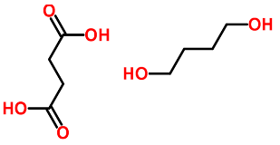 | OC(=O)CCC(=O)O.OCCCCO | 238 | Polymer database
Poly(ethylene succinate |  | 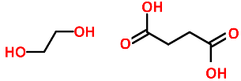 | OC(=O)CCC(=O)O.OCCO | 267 | Polymer database
Poly(1,6-hexylene succinate) |  | 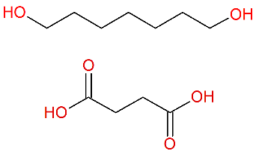 | OC(=O)CCC(=O)O.OCCCCCCO | 220 | Polymer database
Poly(1,3-propylene succinate) |  | 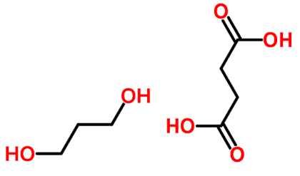 | OC(=O)CCC(=O)O.OCCCO | 232 | Polymer database
Poly(Bisphenol A terephthalate) |  | 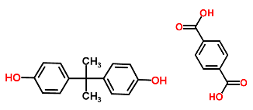 | OC(=O)c1ccc(cc1)C(=O)O.Oc1ccc(cc1)C(C)(C)c2ccc(cc2)O | 472 | Polymer database
Poly[(tetramethylene terephthalate) | PBT |  | OC(=O)c1ccc(cc1)C(=O)O.OCCCCO | 313 | Polymer database
Poly(cyclohexanedimethylene terephthalate) | PCT | 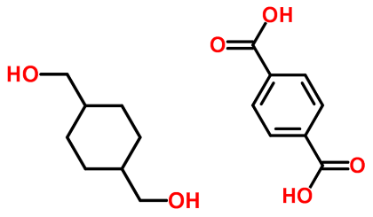 | OC(=O)c1ccc(cc1)C(=O)O.OCC1CCC(CC1)CO | 364 | Polymer database
Poly(ethylene terephthalate) | PET | 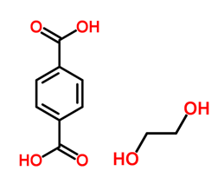 | OC(=O)c1ccc(cc1)C(=O)O.OCCO | 344 | Polymer database
Poly(trimethylene terephthalate) | PTT | 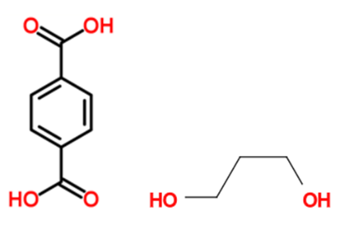 | OC(=O)c1ccc(cc1)C(=O)O.OCCCO | 326 | Polymer database
Poly(vinyl alcohol) | PVOH, PVA | 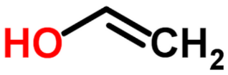 | C{-}(OC(=O)C)C{n+} | 353 | Polymer database
Poly(4-hydroxystyrene) | PVP | 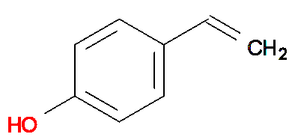 | C=Cc1ccc(cc1)O | 430  473 | Polymer database
Poly(vinyl butyral) | PVB | 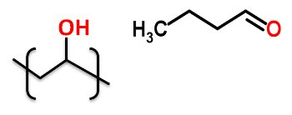 | C{-}C(O){n+}.O=CCCC | 344 | Polymer database
Poly(vinyl formal) | PVF | 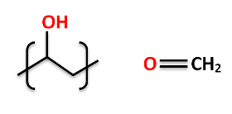 | C{-}C(O){n+}.O=C | 325 | Polymer database
Poly(vinyl acetate) | PVAc  PVA | 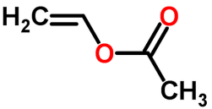 | CC(=O)OC=C | 307 | Polymer database
Poly(vinylbenzoate) |  | 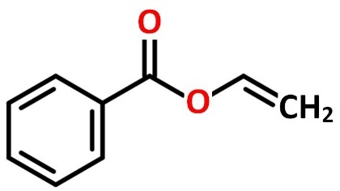 | C=COC(=O)c1ccccc1 | 344 | Polymer database
Poly(vinyl butyrate) | PVB | 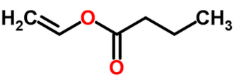 | CCCC(=O)OC=C |  | Polymer database
Poly(vinyl caproate) |  | 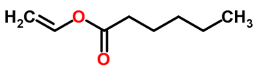 | CCCCCC(=O)OC=C |  | Polymer database
Poly(vinyl formate) |  | 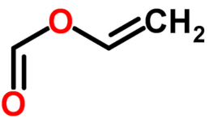 | C=COC=O | 307 | Polymer database
Poly(vinyl propionate |  | 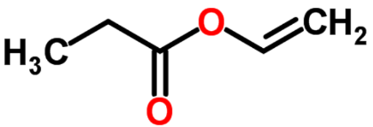 | C=COC(=O)CC | 283 | Polymer database
Poly(vinyl sterate) |  | 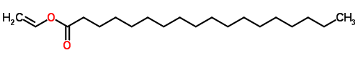 | CCCCCCCCCCCCCCCCCC(=O)OC=C | 318 | Polymer database
Poly(vinyl valerate) |  | 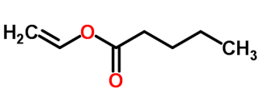 | CCCCC(=O)OC=C |  | Polymer database
Poly(vinyl ethyl ketone) |  | 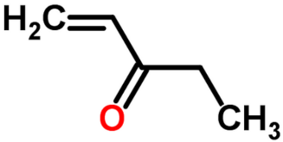 | CCC(=O)C=C | 213 | Polymer database
Poly(vinyl methyl ketone) |  | 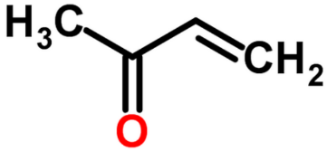 | CC(=O)C=C | 301 | Polymer database
Poly(methyl isopropenyl ketone) |  | 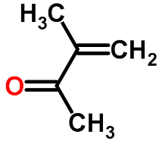 | CC(=O)C(C)=C | 370 | Polymer database
Poly(vinyl phenyl ketone) |  | 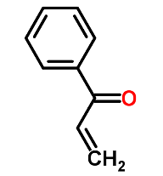 | C=CC(=O)c1ccccc1 | 323 | Polymer database
Poly(butyl vinyl thioether) |  | 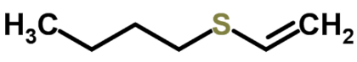 | CCCCSC=C | 253 | Polymer database
Poly(ethyl vinyl thioether) |  | 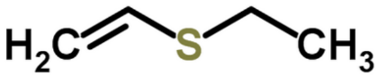 | CCSC=C | 266 | Polymer database
Poly(methyl vinyl thioether) |  | 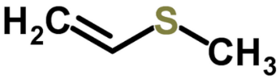 | CSC=C | 272 | Polymer database
Poly(vinyl phenyl sulfide) |  | 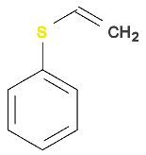 | C=CSc1ccccc1 | 386 | Polymer database
Poly(propyl vinyl thioether) |  | 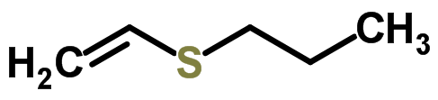 | CCCSC=C |  | Polymer database
poly(acrilomide), para-substituted polystyrenes, POLYACRYLATES (POLYPROPENOATES), Polynitrile, Polyesters, POLYAKLENES (POLYOLEFINS), POLYAMIDES (POLYLACTAMS), POLYANHYDRIDES, POLYDIENES, POLYFUMARATES (POLYBUTENEDIOATES), POLYHALOOLEFINS, POLYFLUOROOLEFINS, POLYCHLOROOLEFINS, POLYEPOXIDES (POLYHYDROXYETHERS) EPOXY & PHENOXY POLYMERS , POLYESTERS, POLYGLYCOLS (POLYETHERS) (MONOMERS: GLYCIDYL ETHERS & CYCLIC ETHERS), POLYKETONES POLYETHERKETONES, POLYETHERSULFONES (POLYSULFONE), POLYFUMARATES (POLYBUTENEDIOATES), POLYGLYCOLS (POLYETHERS) (MONOMERS: GLYCIDYL ETHERS & CYCLIC ETHERS), POLYHALODIENES CHLORINATED AND BROMINATED DIENES, POLYHALOSTYRENES CHLORINATED AND FLUORINATED STYRENES, POLYHYDROXY(METH)ACRYLATES, POLYURETHANES, POLYISOPHTHALATE, POLYITACONATES, (POLYMETHYLENE SUCCINATES), POLYMETHACRYLAMIDES, POLYPHENYLENES (POLYAROMATICS), POLYPHENYLETHERS POLYPHENYLENEOXIDE, POLYETHERSULFONES (POLYSULFONE), POLYSULFIDES POLYTHIOETHERS, POLYSEBACATES, POLYSILOXANES (SILICONES), POLYSUCCINATES, POLYTEREPHTHALATES, POLYVINYL ALCOHOLS & DERIVATIVES, POLYVINYL ESTERS, POLYVINYL KETONES, POLYVINYL SULFIDES (POLYVINYL THIOETHERS),

